# Smart Farmer-IOT Enabled Smart Farming Application

**Project Development Phase**

# Sprint Delivery -4

|  |  |
| --- | --- |
| **Team ID** | PNT2022TMID20067 |
| **Project Name** | Smart Farmer-IOT Enabled Smart Farming Application |

**Web UI:**

**To make the user interact with the software: NODE RED URL :** http://127.0.0.1:1880/

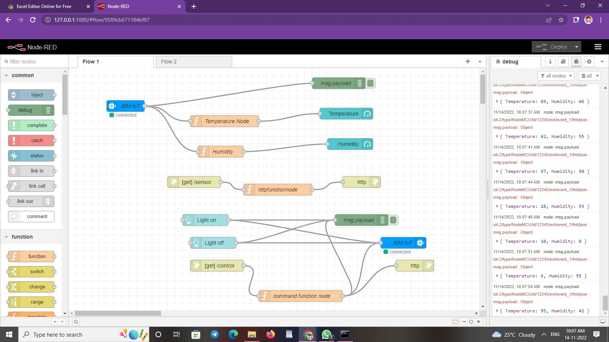

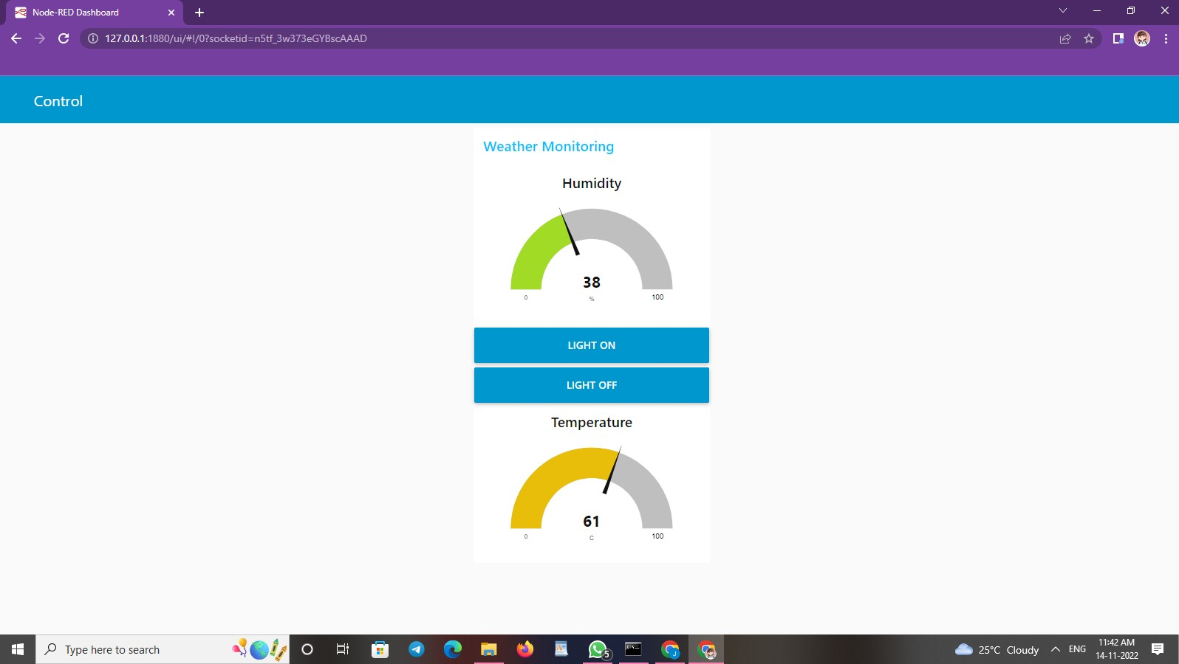**URl :** http://127.0.0.1:1880/ui/#!/0?socketid=DxhTmt9mXlcfkTOsAAAH

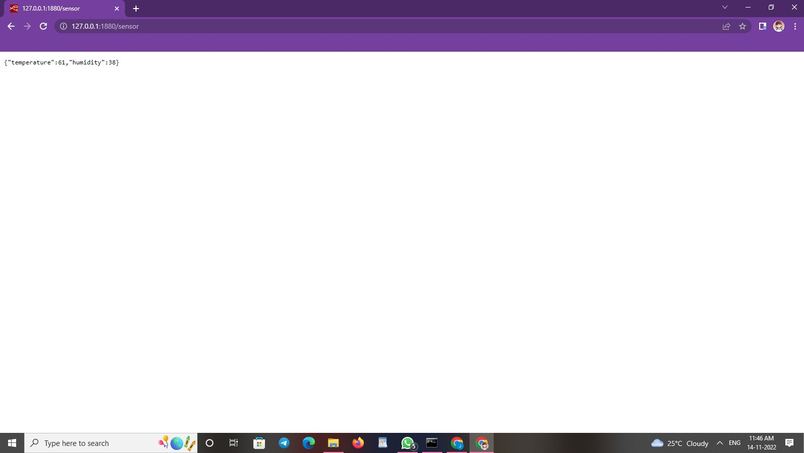**URL:** http://127.0.0.1:1880/sensor